Chapter 2

The Mean definition: The mean, often called the average, is a common way to measure the center of a distribution of data. To compute the mean interest rate, we add up all the interest rates and divide by the number of observations:

The sample mean is often labeled ̄x.

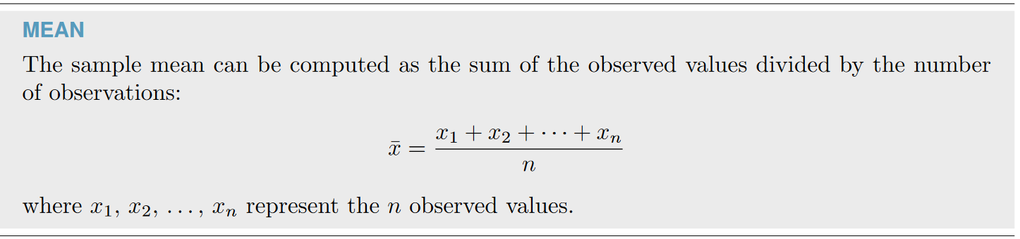

Example:

Find the mean of 8, 5, 7, 10, 15, 21

STEP 1. 8+5+7+10+15+21 = 66

Step 2. 66/6 = 11

Step 3. Mean = 11

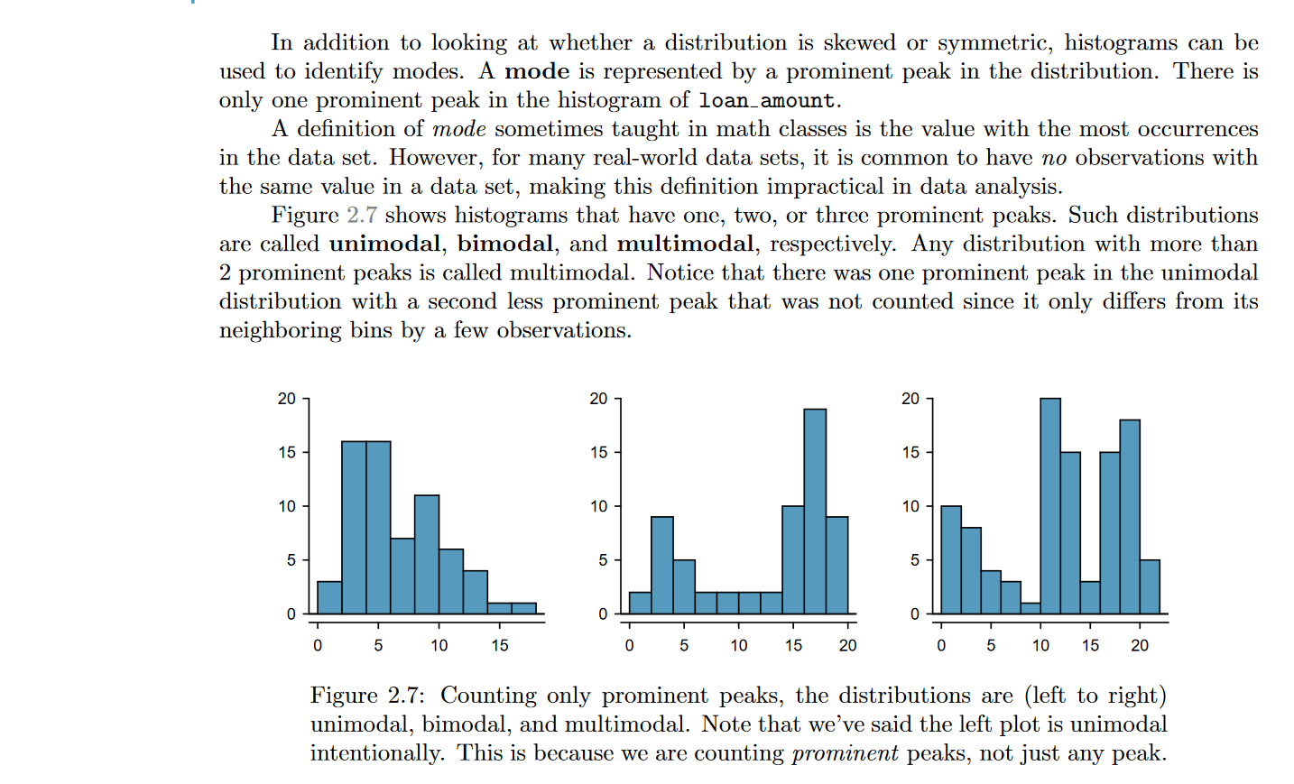

Practice Question

What is the mode of the following numbers?

12,11,14,10,8,13,11,9

Mode = 11

